**Eye-Net**

**Detecting Diabetic Retinopathy With Deep Learning**

**Objective**

Diabetic retinopathy is the leading cause of blindness in the working-age population of the developed world. The condition is estimated to affect over 93 million people.

The need for a comprehensive and automated method of diabetic retinopathy screening has long been recognized, and previous efforts have made good progress using image classification, pattern recognition, and machine learning. With photos of eyes as input, the goal of this capstone is to create a new model, ideally resulting in realistic clinical potential.

The motivations for this project are twofold:

* Image classification has been a personal interest for years, in addition to classification on a large scale data set.
* Time is lost between patients getting their eyes scanned (shown below), having their images analyzed by doctors, and scheduling a follow-up appointment. By processing images in real-time, EyeNet would allow people to seek & schedule treatment the same day.

[](https://github.com/gregwchase/dsi-capstone/blob/master/images/readme/dr_scan.gif)

**Table of Contents**

1. [Data](https://github.com/gregwchase/dsi-capstone#data)
2. [Exploratory Data Analysis](https://github.com/gregwchase/dsi-capstone#exploratory-data-analysis)
3. [Pre-processing](https://github.com/gregwchase/dsi-capstone#preprocessing)
   * [Download Images to EC2](https://github.com/gregwchase/dsi-capstone#download-all-images-to-ec2)
   * [Crop & Resize Images](https://github.com/gregwchase/dsi-capstone#crop-and-resize-all-images)
   * [Rotate and Mirror All Images](https://github.com/gregwchase/dsi-capstone#rotate-and-mirror-all-images)
4. [CNN Architecture](https://github.com/gregwchase/dsi-capstone#neural-network-architecture)
5. [Results](https://github.com/gregwchase/dsi-capstone#results)
6. [Next Steps](https://github.com/gregwchase/dsi-capstone#next-steps)
7. [References](https://github.com/gregwchase/dsi-capstone#references)

**Data**

The data originates from a [2015 Kaggle competition](https://www.kaggle.com/c/diabetic-retinopathy-detection). However, is an atypical Kaggle dataset. In most Kaggle competitions, the data has already been cleaned, giving the data scientist very little to pre-process. With this dataset, this isn't the case.

All images are taken of different people, using different cameras, and of different sizes. Pertaining to the [preprocessing](https://github.com/gregwchase/dsi-capstone" \l "preprocessing) section, this data is extremely noisy, and requires multiple pre-processing steps to get all images to a useable format for training a model.

The training data is comprised of 35,126 images, which are augmented during pre-processing.

## Overview

Diabetic retinopathy (die-uh-BET-ik ret-ih-NOP-uh-thee) is a diabetes complication that affects eyes. It's caused by damage to the blood vessels of the light-sensitive tissue at the back of the eye (retina).

At first, diabetic retinopathy may cause no symptoms or only mild vision problems. Eventually, it can cause blindness.

The condition can develop in anyone who has type 1 or type 2 diabetes. The longer you have diabetes and the less controlled your blood sugar is, the more likely you are to develop this eye complication.

# Symptoms

You might not have symptoms in the early stages of diabetic retinopathy. As the condition progresses, diabetic retinopathy symptoms may include:

* Spots or dark strings floating in your vision (floaters)
* Blurred vision
* Fluctuating vision
* Impaired colour vision
* Dark or empty areas in your vision
* Vision loss
* Diabetic retinopathy usually affects both eyes.

# When to see a doctor

Careful management of your diabetes is the best way to prevent vision loss. If you have diabetes, see your eye doctor for a yearly eye exam with dilation — even if your vision seems fine. Pregnancy may worsen diabetic retinopathy, so if you're pregnant, your eye doctor may recommend additional eye exams throughout your pregnancy.

Contact your eye doctor right away if your vision changes suddenly or becomes blurry, spotty or hazy.

## Causes

* [Illustration showing severe nonproliferative diabetic retinopathy 
  ](https://www.mayoclinic.org/-/media/kcms/gbs/patient-consumer/images/2013/08/26/10/42/ds00447_im02507_r7_retinopathythu_jpg.png)

### **Diabetic retinopathy**

Over time, too much sugar in your blood can lead to the blockage of the tiny blood vessels that nourish the retina, cutting off its blood supply. As a result, the eye attempts to grow new blood vessels. But these new blood vessels don't develop properly and can leak easily.

There are two types of diabetic retinopathy:

* **Early diabetic retinopathy.** In this more common form — called non-proliferative diabetic retinopathy (NPDR) — new blood vessels aren't growing (proliferating).

When you have NPDR, the walls of the blood vessels in your retina weaken. Tiny bulges (microaneurysms) protrude from the vessel walls of the smaller vessels, sometimes leaking fluid and blood into the retina. Larger retinal vessels can begin to dilate and become irregular in diameter, as well. NPDR can progress from mild to severe, as more blood vessels become blocked.

Nerve fibres in the retina may begin to swell. Sometimes the central part of the retina (macula) begins to swell (macular edema), a condition that requires treatment.

* **Advanced diabetic retinopathy** Diabetic retinopathy can progress to this more severe type, known as proliferative diabetic retinopathy. In this type, damaged blood vessels close off, causing the growth of new, abnormal blood vessels in the retina, and can leak into the clear, jelly-like substance that fills the centre of your eye (vitreous).

Eventually, scar tissue stimulated by the growth of new blood vessels may cause the retina to detach from the back of your eye. If the new blood vessels interfere with the normal flow of fluid out of the eye, pressure may build up in the eyeball. This can damage the nerve that carries images from your eye to your brain (optic nerve), resulting in glaucoma.

## Risk factors

Anyone who has diabetes can develop diabetic retinopathy. Risk of developing the eye condition can increase as a result of:

* Duration of diabetes — the longer you have diabetes, the greater your risk of developing diabetic retinopathy
* Poor control of your blood sugar level
* High blood pressure
* High cholesterol
* Pregnancy
* Tobacco use
* Being African-American, Hispanic or Native American

## Complications

Diabetic retinopathy involves the abnormal growth of blood vessels in the retina. Complications can lead to serious vision problems:

* **Vitreous haemorrhage.** The new blood vessels may bleed into the clear, jelly-like substance that fills the centre of your eye. If the amount of bleeding is small, you might see only a few dark spots (floaters). In more-severe cases, blood can fill the vitreous cavity and completely block your vision.

Vitreous haemorrhage by itself usually doesn't cause permanent vision loss. The blood often clears from the eye within a few weeks or months. Unless your retina is damaged, your vision may return to its previous clarity.

* **Retinal detachment.** The abnormal blood vessels associated with diabetic retinopathy stimulate the growth of scar tissue, which can pull the retina away from the back of the eye. This may cause spots floating in your vision, flashes of light or severe vision loss.
* **Glaucoma.** New blood vessels may grow in the front part of your eye and interfere with the normal flow of fluid out of the eye, causing pressure in the eye to build up (glaucoma). This pressure can damage the nerve that carries images from your eye to your brain (optic nerve).
* **Blindness.** Eventually, diabetic retinopathy, glaucoma or both can lead to complete vision loss.

**Exploratory Data Analysis**

The very first item analyse was the training labels. While there are five categories to predict against, the plot below shows the severe class imbalance in the original dataset.

A clinician has rated the presence of diabetic retinopathy in each image on a scale of 0 to 4, according to the following scale:

* 0 - No DR
* 1 - Mild
* 2 - Moderate
* 3 - Severe
* 4 - Proliferative DR

Your task is to create an automated analysis system capable of assigning a score based on this scale.

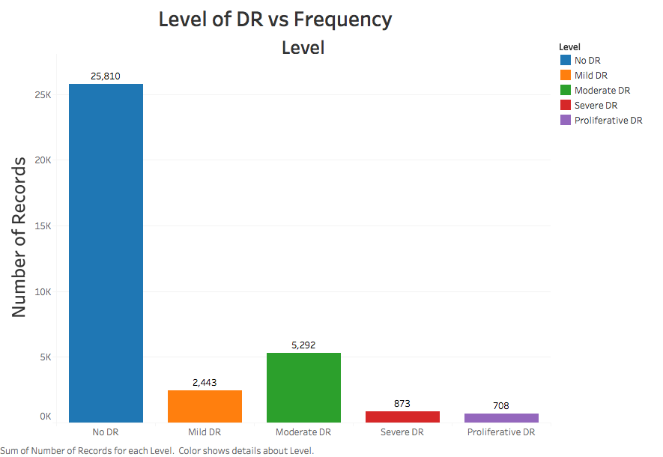

Of the original training data, 25,810 images are classified as not having retinopathy, while 9,316 are classified as having retinopathy.

Due to the class imbalance, steps taken during [***pre-processing***](https://github.com/gregwchase/dsi-capstone#preprocessing) in order to rectify the imbalance, and when training the model.

Furthermore, the variance between images of the eyes is extremely high. The first two rows of images show class 0 (no retinopathy); the second two rows show class 4 (proliferative retinopathy).

[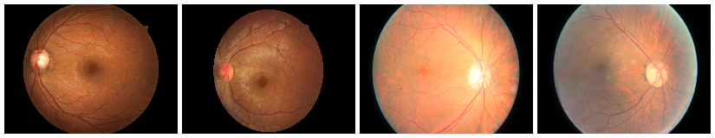](https://github.com/gregwchase/dsi-capstone/blob/master/images/readme/No_DR_white_border_1.png) [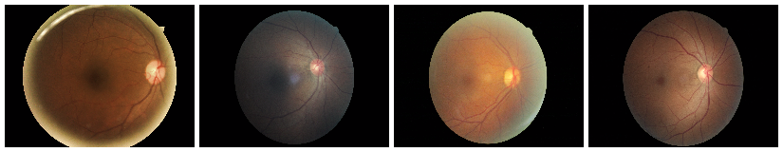](https://github.com/gregwchase/dsi-capstone/blob/master/images/readme/No_DR_white_border_2.png)  
  
[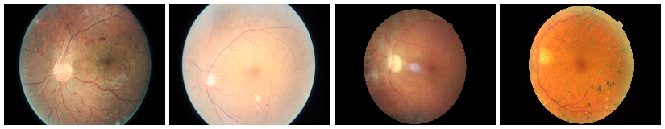](https://github.com/gregwchase/dsi-capstone/blob/master/images/readme/Proliferative_DR_white_border_1.png) [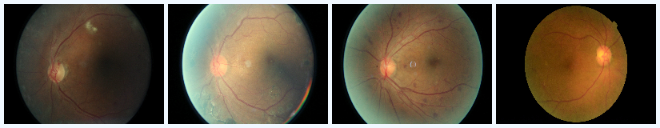](https://github.com/gregwchase/dsi-capstone/blob/master/images/readme/Proliferative_DR_white_border_2.png)

**Pre-processing**

The pre-processing pipeline is the following:

1. Crop & resize all images using the [resizing script](https://github.com/gregwchase/dsi-capstone/blob/master/src/resize_images.py) and the [pre-processing script](https://github.com/gregwchase/dsi-capstone/blob/master/src/preprocess_images.py).
2. Rotate & mirror all images using the [rotation script](https://github.com/gregwchase/dsi-capstone/blob/master/src/rotate_images.py).
3. Convert all images to array of NumPy arrays, using the [conversion script](https://github.com/gregwchase/dsi-capstone/blob/master/src/image_to_array.py).

### **Crop and Resize All Images**

All images were scaled down to 256 by 256. Despite taking longer to train, the detail present in photos of this size is much greater then at 128 by 128.

Additionally, 403 images were dropped from the training set. Scikit-Image raised multiple warnings during resizing, due to these images having no color space. Because of this, any images that were completely black were removed from the training data.

### **Rotate and Mirror All Images**

All images were rotated and mirrored. Images without retinopathy were mirrored; images that had retinopathy were mirrored, and rotated 90, 120, 180, and 270 degrees.

The first images show two pairs of eyes, along with the black borders. Notice in the cropping and rotations how the majority of noise is removed.

[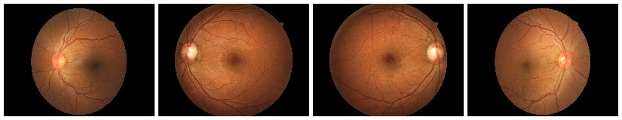](https://github.com/gregwchase/dsi-capstone/blob/master/images/readme/sample_images_unscaled.jpg)[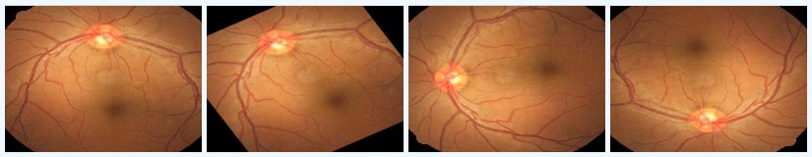](https://github.com/gregwchase/dsi-capstone/blob/master/images/readme/17_left_horizontal_white.jpg)

After rotations and mirroring, the class imbalance is rectified, with a few thousand more images having retinopathy. In total, there are 106,386 images being processed by the neural network.

[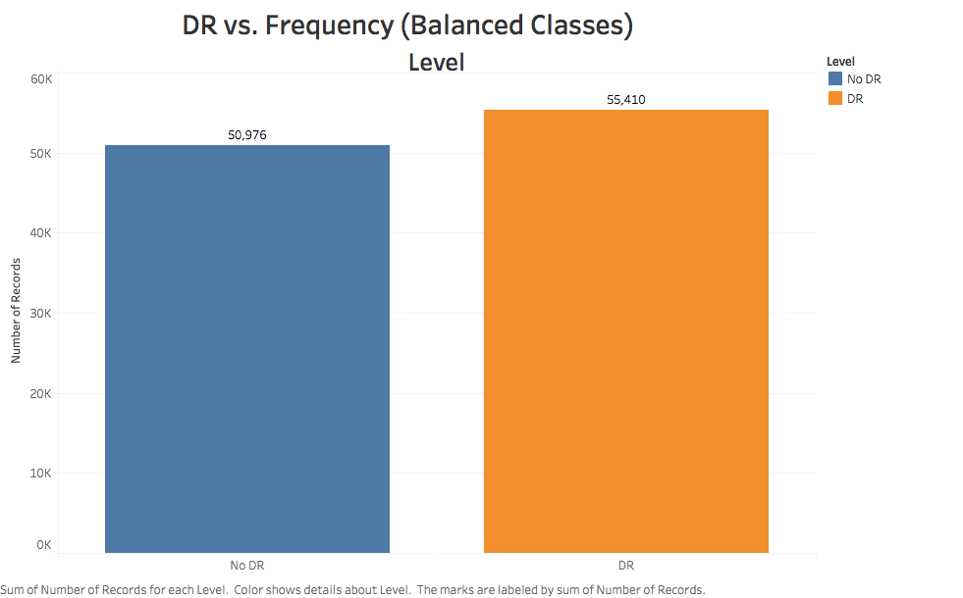](https://github.com/gregwchase/dsi-capstone/blob/master/images/eda/DR_vs_frequency_balanced.png)

## Neural Network Architecture

The model is built using Keras, utilizing TensorFlow as the backend. TensorFlow was chosen as the backend due to better performance over Theano, and the ability to visualize the neural network using Tensor Board.

For predicting two categories, EyeNet utilizes three convolutional layers, each having a depth of 32. A Max Pooling layer is applied after all three convolutional layers with size (2,2).

After pooling, the data is fed through a single dense layer of size 128, and finally to the output layer, consisting of 2 softmax nodes.

[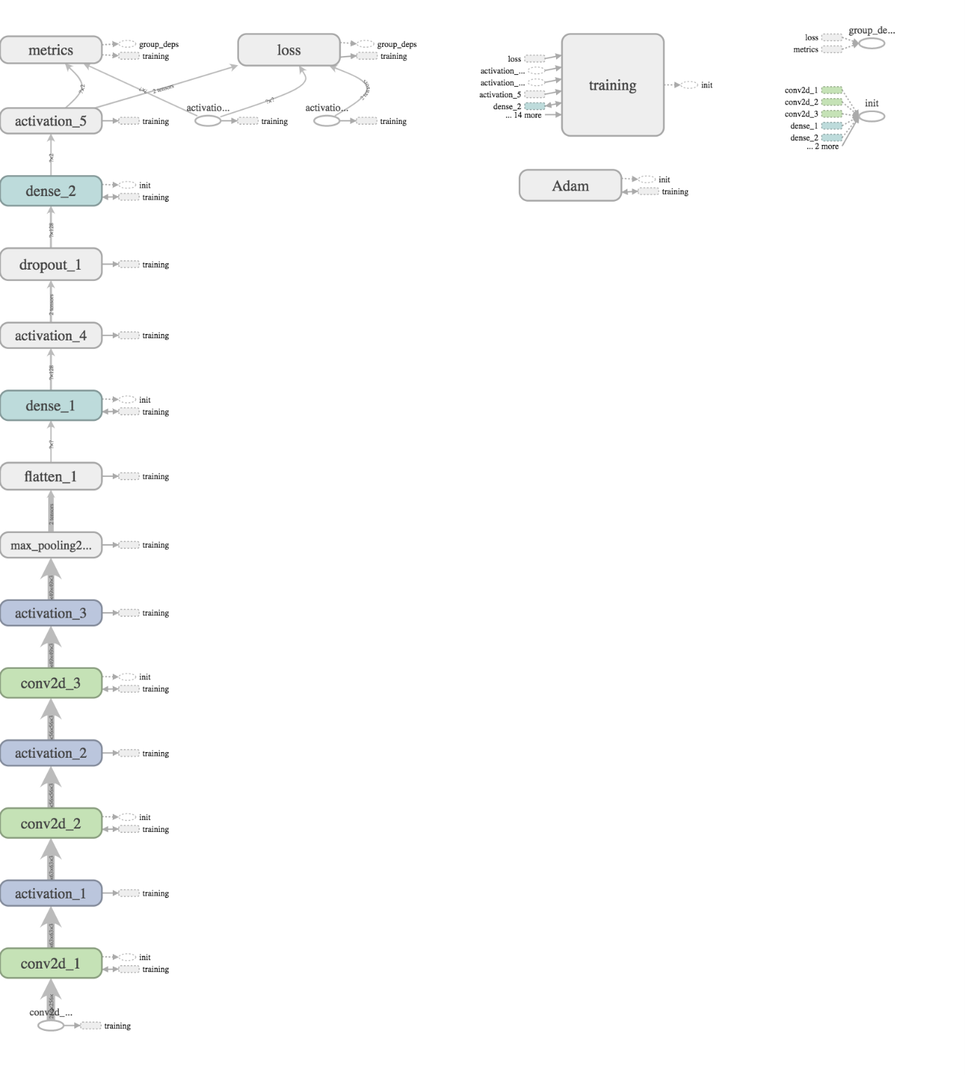](https://github.com/gregwchase/dsi-capstone/blob/master/images/readme/cnn_two_classes_tensorboard.png)

## Results

The EyeNet classifier was created to determine if a patient has retinopathy. The current model returns the following scores.

| **Metric** | **Value** |
| --- | --- |
| Accuracy (Train) | 82% |
| Accuracy (Test) | 80% |
| Precision | 88% |
| Recall | 77% |

So, why does the neural network perform this way? Besides the class imbalance, the cropping is definitely helping in the network's performance. By not having extra black parts in the images, the network is able to process only the eye itself.

## Next Steps

1. Program the neural network to retrain with new photos. This is a common practice, and only serves to optimize the model. Checks would be put in place to validate the images before being added to the classifier, in order to prevent low quality images from altering the classifier too drastically.
2. Port the Keras model to CoreML, and deploy to an EyeNet iOS application. CoreML is a framework designed by Apple for adding machine learning to iOS devices. This allows the ability of Python developers to export their models, convert the file to a .mlmodel file, and add the file to the iOS development cycle.